# Ethnic Placement in the city – IBM Capstone Project

## Introduction

In this project, we are going to found a automatic way to see the cluster of the ethnic group in a area. In many times, only the local people know which area in the city is for Certain group. Fox example, there are Chinese Town, Korea Town, or Japanese town in every city. However, this information is not shown on the map. If I were the new real estate agent and looking for place for my client, I would want to know which area is best suite for my client. Most new homeowner would prefer to live nearby their cultural group. If a newcomer of the city try to settle, it would take trial and error to found out actually the first place that he or she choose may not be the best ideal place that he would like to live in. This project is to explore a machine learning way to show the hidden information of ethnic gathering group.

## Methodology and Data

I am going to use Foursquare api to gather the venue type in the area. Then I will use k-mean to see if cluster exist for each of the following group:

* Italian
* Chinese
* Korean
* Japanese
* Indian
* Latino

The list may not be inclusive that not all the ethnic group is listed. Then I will use Folium map and heatmap. I will use Los Angeles to verify my data. Then I will run Bay area, Kansas City, Atlanta, and Washington DC to explore the ehnic group distribution

Result

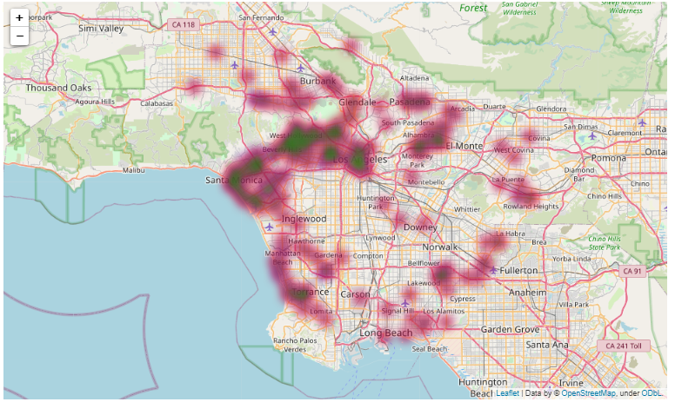

The above is the Chinese restaurant heatmap with the information come back from foursquare api. Due to the limitation of api, it can only return 300 venues, since I am only using the free version of foursquare api.

Based on my knowledge of the area and the demographic, the map is showing the opposite of what I know. In particular, there is way more Chinese in Northeast of Los Angeles than any area in Los Angeles, CA. Therefore the test fail the verification step and we stop the test here.

<https://github.com/philiplaucpa/Coursera_Capstone/blob/main/IBM%20Capstone%20Project.ipynb>

Discussion

By getting the restaurant venue to see the ethnic placement position in the area may not be a good idea. It could be that area of people love certain food, like Japanese food, and there is a lot of Japanese restaurant in the area, that doesn’t mean there is a lot of Japanese living in the nearby area. We often have a wrong perception that people would like their own cultural food in nearby area. This research prove the opposite that the restaurant depend on the taste of the food, not by people’s original culture.

Conclusion

I learn from the research that people’s taste is not often the same taste as their own culture. People love different type of food. The result may prove the opposite that the area with the most restaurants of particular culture may not have much of the population of that culture. However, the above statement may require separate test to prove it. This research prove that the number of particular cultural restaurant does not correlate with the population density of the corresponding ethnics.